# Task 7 (4.4)

**Create onscreen help to assist the users of a computer program.**

## Help Menu

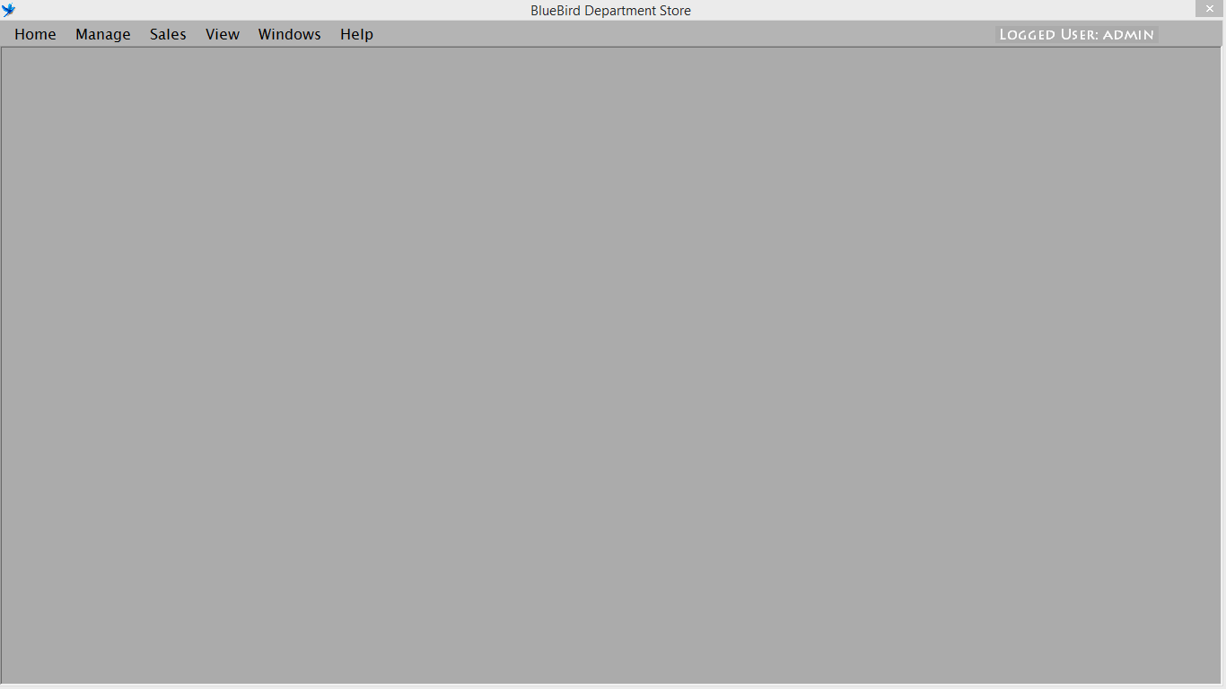To offer the onscreen help to the user, an inbuilt help feature is developed. With help of help menu user can read onscreen document than can assist user to operate the system. User can access this help screen just by clicking on the help menu.

Figure Help Menu

## Developing onscreen help

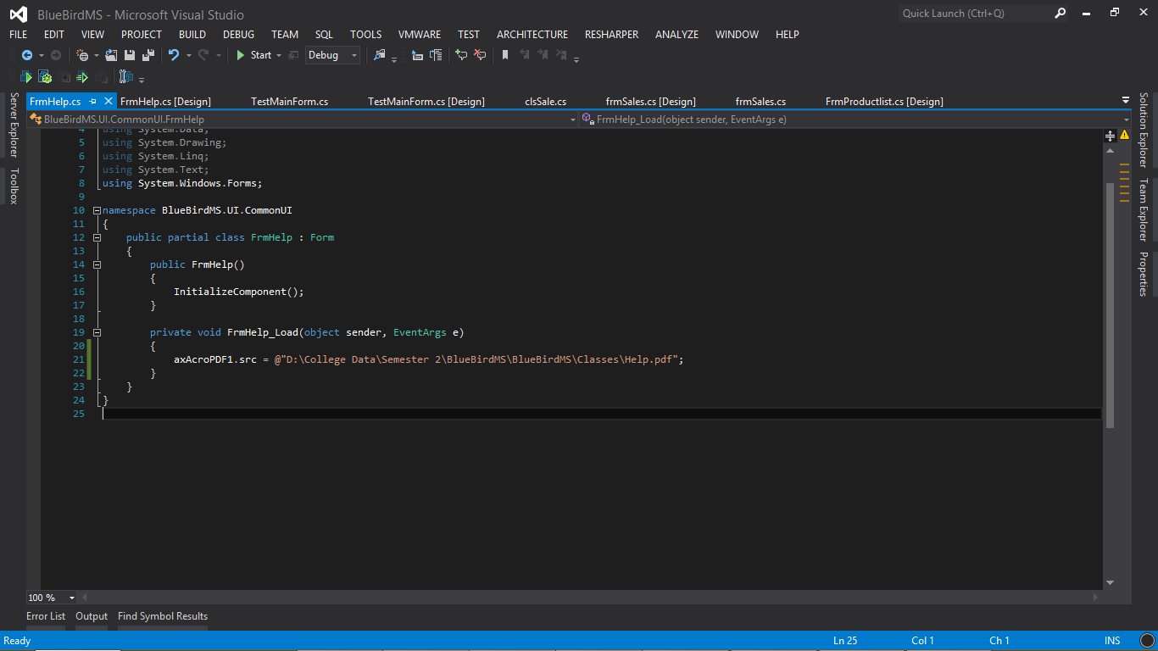

Figure Implementing Onscreen Help

## Onscreen Help

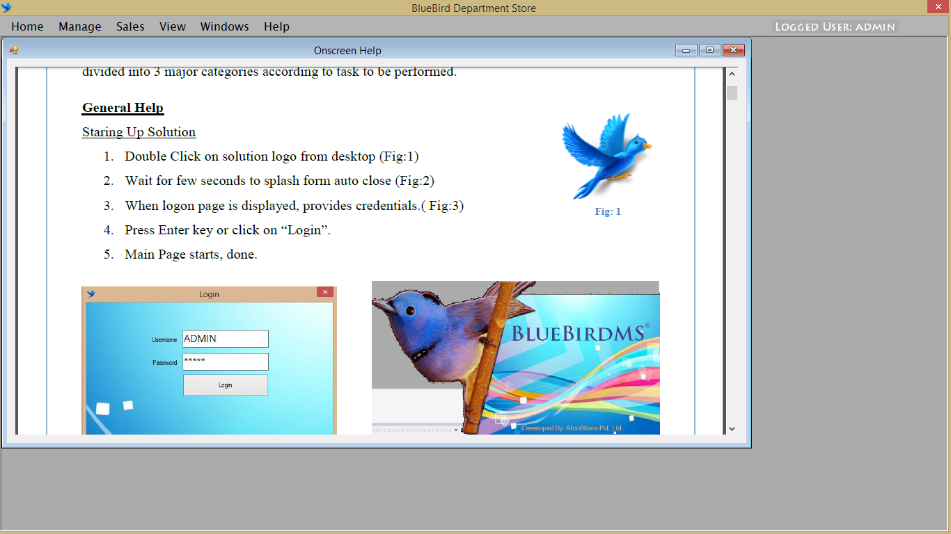

Figure Onscreen help document in system